**Lab Number: 05**

**TO BECOME FAMILIAR WITH RMI OBJECT SERIALIZATION**

* Develop any simple application to demonstrate object passing in RMI. (Expl: Make a class of your own and use its objects as arguments and return types for RMI).

**Interface**

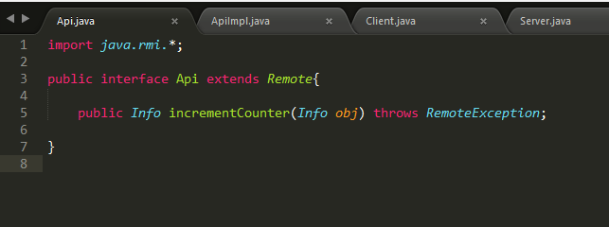

**Remote Class**

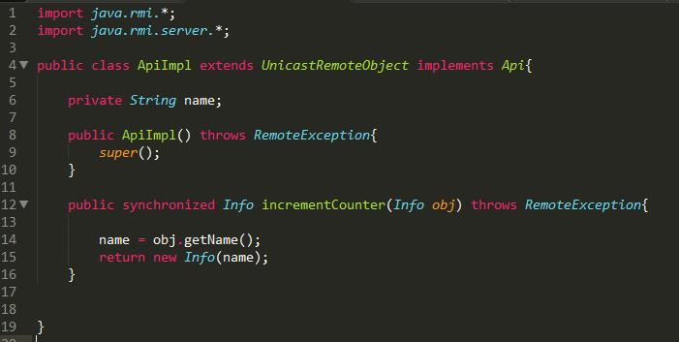

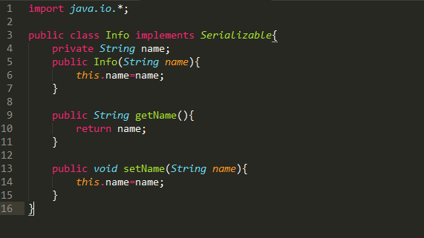

**Client Main Class**

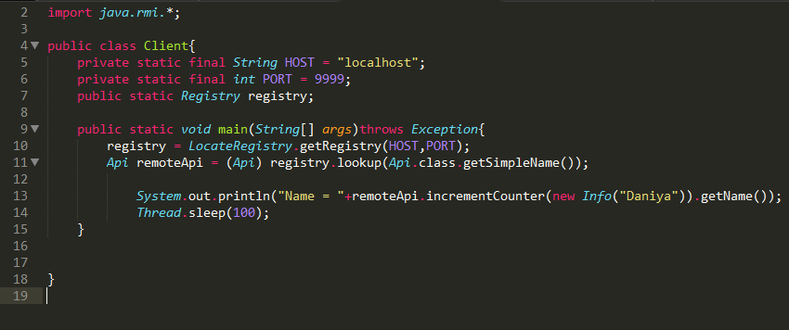

**Server Main Class**

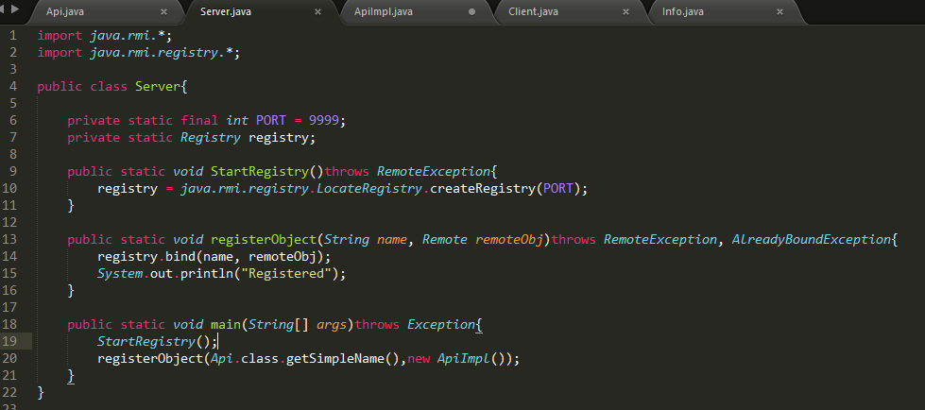

**Output**

